Ionic compounds→ electrons are shared
→ only form when the compound is a lower energy state than the individual atoms/ions alone

$Coulomb's law ∝ lattice energy$

Lattice energy $(ΔH$$latt$$or U)$: energy needed to form a crystal
↳EXOTHERMIC (-)
Heat of solution $(ΔH$$sol'n$$)$: energy involved in going from solid→ liquid state
↳ ENDOTHERMIC (+)
Atomization (sublimation) energy $(ΔH$$sub$$or ΔH$$atom$$)$: energy needed to go from solid→ gaseous state
↳ ENDOTHERMIC (+)
Ionization energy $(I.E)$: energy required to remove an electron and turn an atom→ ion
↳ ENDOTHERMIC (+)
Bond enthalpy (dissociation) $(B.E or ΔH$$dissociation$$)$: energy required to break a bond
↳ ENDOTHERMIC (+)
Electron affinity $(E.A)$: energy involved in adding an electron to an atom turning it into an ion
↳ EXOTHERMIC (-)
Heat of formation $(ΔH$$f$$°)$: heat involved in the formation of an ionic compound
↳ EXOTHERMIC (-)
Heat of hydration $(ΔH$$hydr$$)$: energy involved in the (favorable) transition from ion in gas state→ hydrated ions
↳ EXOTHERMIC (-)

$ΔH$$f$$°$= $ΔH$$sub$ + $B.E$ + $I.E$ + $E.A$ + $ΔH$$latt$

IONIC COMPOUNDS FORM DUE TO LATTICE ENERGY
→ since lattice energy is exothermic (negative) it is basically bonus energy (it's like a reward)
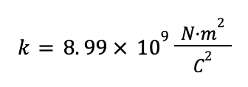
→ LATTICE ENERGY IS WHAT MAKES FORMING AN IONIC COMPOUND FAVORABLE

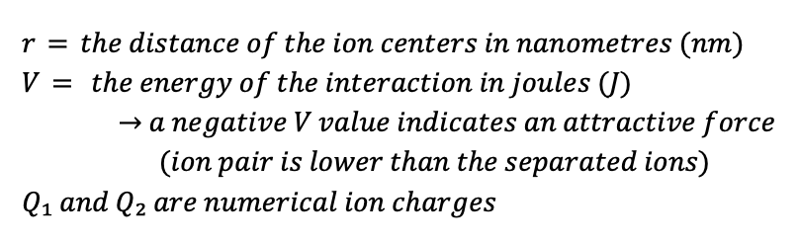
$Lattice energy (U) = k$$\left(\frac{Q₁Q₂}{R^{2}}\right)$

$V= 2.31×{10}^{-19}$$\left(\frac{Q₁Q₂}{r}\right)$

When comparing atoms of similar size:

When finding the larger atom or ion;

Of the same atom→ More electrons (negative charge) = larger
→ More protons (positive charge) = smaller

For noble gasses vs other elements→ full shell is largest, even when comparing atoms with the same number
of electrons

Isoelectronic atoms/ions→ have the same electron configuration→ the one with the lowest effective nuclear
charge→ least protons→ is largest

Covalent bonds→ when electrons are shared, not taken

When two of the same (or equally electronegative) atoms bond covalently→ electrons are shared evenly
→ NONPOLAR
When two unequally electronegative atoms bond covalently→ electrons shared unevenly
→ POLAR

Electronegativity→ the measure of an atom's ability to attract shared electrons towards itself
Top right corner→ high electronegativity
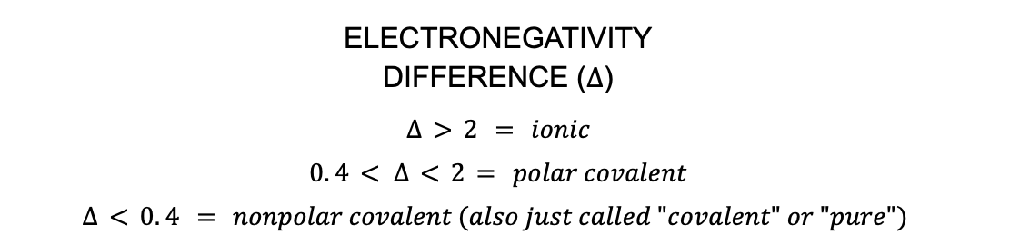
Low left corner→ low electronegativity

Highly electronegative + low electronegativity→ Generally ionic
Equal electronegativity + equal electronegativity→ nonpolar covalent
Somewhat electronegative + slightly less electronegative→ polar covalent

Low ionization energy→ low electronegativity
Low electron affinity→ low electronegativity

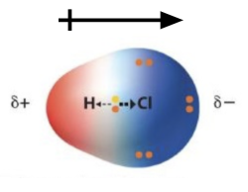
HETERONUCLEAR DIATOMICS (2 different atoms)→ DO NOT SHARE ELECTRONS EVENLY

DIPOLES→ drawn with an arrow with a line through it indicating the positive end and pointing towards the negative end

A DIPOLE MOMENT→ A polar molecule with a center of positive charge AND a center of negative charge
→ Being polar is a prerequisite for having a dipole, but NOT ALL polar molecules have a
dipole
→ DIPOLES ARE VECTORS→ they can be added, subtracted, and cancel eachother out

TO CALCULATE POLARITY OF A BOND→ Take the electronegativity of 1 atom and subtract it from that of the second number

NON POLAR→ no dipole moment :(

Dipoles > induced dipoles

Forming bonds can also be calculated with: $\sum{}B.E$$reactants$$- \sum{}B.E$$Products$
★ IN THE GAS PHASE THE $\sum{}ΔH$$Products$ FORMED SHOULD BE EXOTHERMIC! (NEGATIVE)

LEWIS STRUCTURES

RULES FOR DRAWING LEWIS STRUCTURES

- FIND THE MOLECULAR FORMULA
  - Identify the central atom

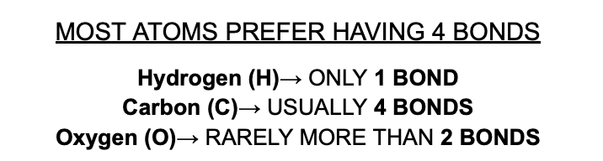
- COUNT THE NUMBER OF VALENCE ELECTRONS FROM EACH ATOM
  - ONLY from the s and p orbitals
    - FOR IONS→ add an electron for (-) ions
→ take away an electron for (+) ions

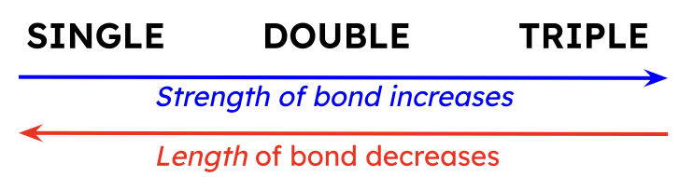
- ADD ALL THE VALENCE ELECTRONS
  - Place pairs of 2 electrons between each atom
    - SINGLE BONDS→ 2 electrons, –
    - DOUBLE BONDS→ 4 electrons, =
    - TRIPLE BONDS→ 6 electrons, ☰

- PLACE ELECTRONS AROUND OUTER ATOMS
  - Ensure octets (8 electrons) or duets (2 electrons)

- DRAW A RING AROUND ATOMS WITH FULL OCTETS

HOW TO CHOOSE A CENTRAL ATOM→ Choose the atom in the compound that is the HIGHEST PERIOD and
FARTHEST TO THE LEFT of the periodic table
→THE CENTRAL ATOM MUST BE ABLE TO SHARE ELECTRONS

EXPANDED OCTETS→ when atoms TAKE ELECTRONS and PROMOTE THEM to AVAILABLE D-ORBITALS
- Occurs in HIGHLY ELECTRONEGATIVE TERMINAL ATOMS
- When the atom has BETWEEN 10-12 VALENCE ELECTRONS
- OCCURS WITH 3RD PERIOD NONMETAL CENTRAL ATOMS AND BELOW

IONS→ MOVE their electrons around to form BETTER and MORE STABLE STRUCTURES
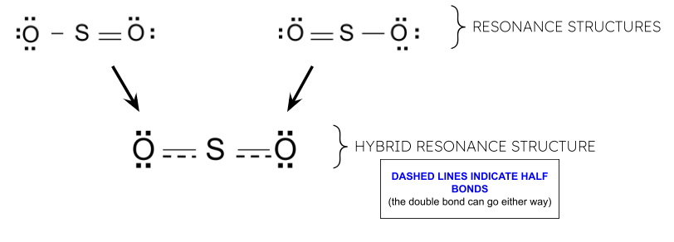
RESONANCE STRUCTURES→ various forms of the same lewis structure

HYBRID RESONANCE STRUCTURES→ a combination of resonance structures for a compound represented by one structure (typically done using dashed lines)

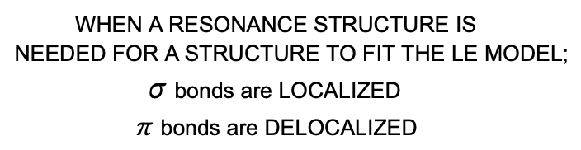
WHEN CHOOSING WHICH RESONANCE STRUCTURE IS BEST

- SMALLER CHARGED STRUCTURE IS BETTER
  - The smallest sum of all individual formal charges added together is best

- +/- CHARGES ARE FARTHEST APART
  - A positive formal charged atom is as farthest as possible from that of a negative atom

- THE MOST ELECTRONEGATIVE ATOM HAS THE MOST NEGATIVE FORMAL CHARGE
- INDIVIDUAL FORMAL CHARGES MUST ADD TO THE OVERALL CHARGE

FORMAL CHARGE→ the individual charge of atoms in a structure. Each value used in calculating formal
charge is that experienced ONLY by the SPECIFIC ATOM
VSEPR

VALENCE SHELL ELECTRON REPULSION THEORY→ VSEPR
- ASSIGNS SHAPES BASED ON LONE PAIRS BETWEEN BONDS AND ATOMS
  - NOT THE PAULI PRINCIPLE
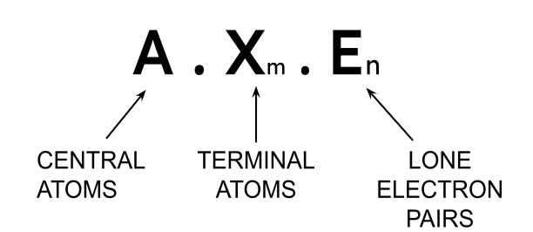

★ Total number of electron groups around the central atom = (m + n)

★ LONE PAIRS TAKE UP MORE SPACE THAN BONDING ELECTRON PAIRS

★ TENDS TO COMPRESS BONDS BETWEEN THE ATOMS
~ INCREASED # of electron pairs→ DECREASED bond angles

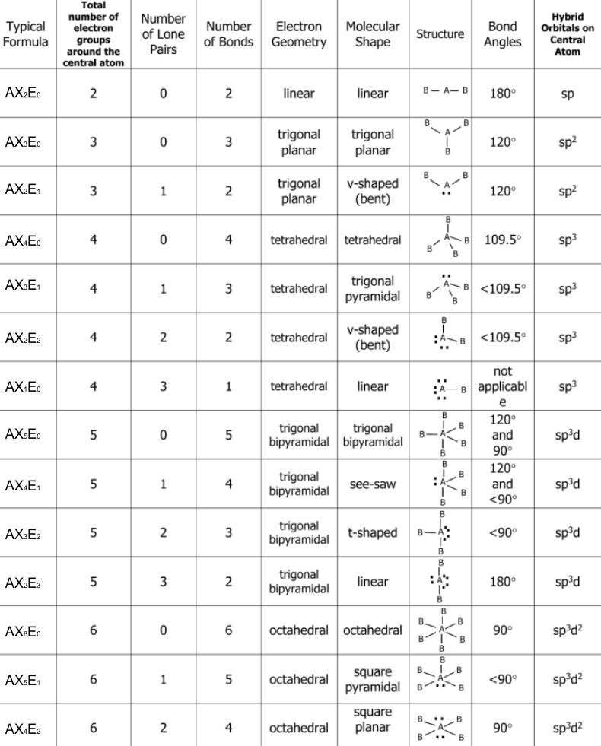

- ONLY WORKS FOR SIMPLE STRUCTURES
  - Bond lengths are NOT ALWAYS EQUAL

- VSEPR DOESN’T WORK FOR ISOELECTRONIC SPECIES
  - ✖ Transition metals
  - ✖ Elements in the d-block

- S-ORBITAL VALENCE ELECTRONS DO NOT PARTICIPATE IN BONDING

★ T-SHAPED and SEESAW STRUCTURES ARE
EXTREMELY UNSTABLE AND UNFAVORABLE
STRUCTURES

MEANING OF THE LINES IN STICK NOTATION

KNOW THIS!

