CELL STRUCTURE & FUNCTION
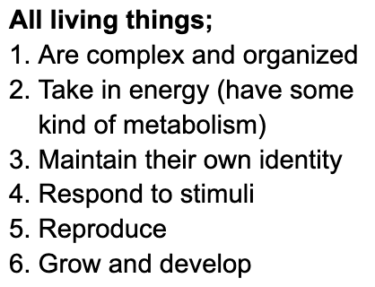
Cells are the fundamental units of life, and also the smallest units of life
- Being the smallest units of life means that anything beyond the cell does not
truly express the characteristics of life

Cell size is limited by 3 main things;
- Adequate surface area-volume ratio
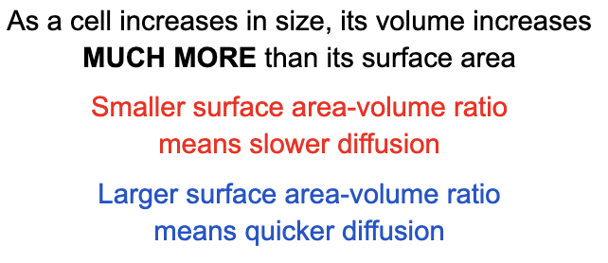
- Rates of molecule diffusion
- Adequate local concentrations of specific molecules

Cell size limits cellular activities, such as;
- RATES at which molecules move around the cell
- FREQUENCIES of molecule collisions
- The IMPORTING and EXPORTING of nutrients and wastes

Large cells often compensate for being large by;
- Being ELONGATED (elongation keeps the surface area to volume ratio relatively high)
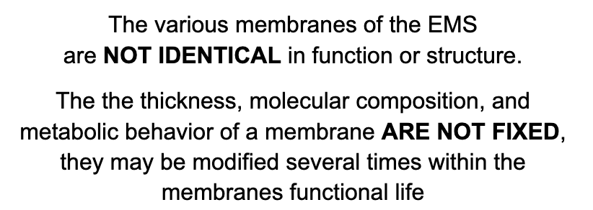
- Having PROTRUSIONS (such as villi which increase the surface area of the cell)

Cell Organelles
- DISCRETE structural bodies within cells
- carry out specific functions
- Are NOT considered alive
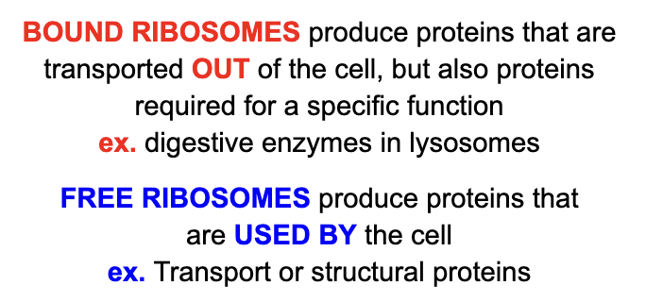
Benefits of having organelles;
- INCOMPATIBLE chemical reactions are separated
- Cellular activities are completed MORE EFFICIENTLY

Endo-membrane system (EMS)
- Group of cell structures that work together
  - CONNECTED mostly by their membranes
  - UNIFYING CHARACTERISTIC is lipid bilayer with proteins attached to either side spanning through members

- Members include;
  - NUCLEAR ENVELOPE→ Connected to endoplasmic reticulum
  - THE ENDOPLASMIC RETICULUM→ ROUGH ER carries ribosomes (BOUND RIBOSOMES) that produce proteins
  - VARIOUS VESICLES→ Transport Vesicles take proteins from ER to the CIS-FACE of the Golgi
  - GOLGI APPARATUS→ Golgi packages, modifies, and gives export tags to proteins and lipids
  - LYSOSOMES→ Site for intracellular digestion
  - THE CELL MEMBRANE→ Destination for building or export

EMS Functions;
- SYNTHESIS of proteins
- Protein (and lipid) TRANSPORT into membranes and organelles, or out of the cell

- METABOLISM and MOVEMENT of lipids
- DETOXIFICATION of poisons
- REGULATE protein traffic
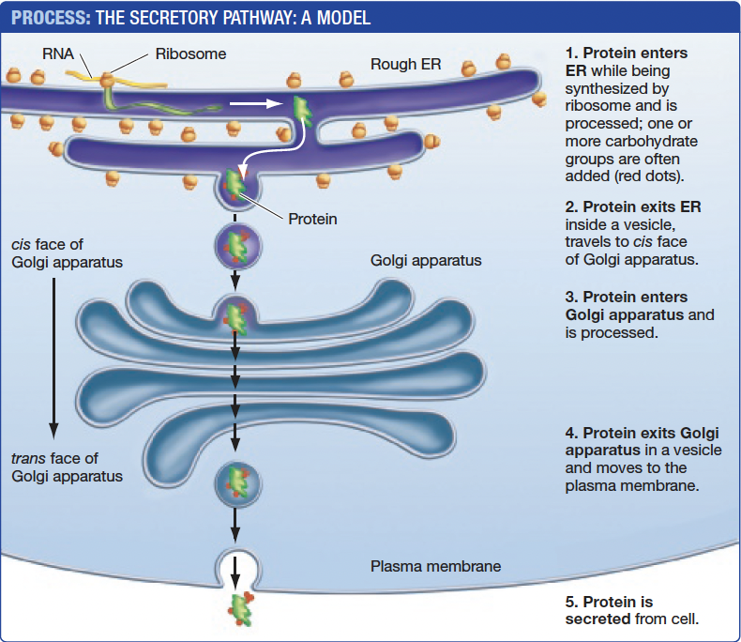
The Secretory Pathway
- The protein is MANUFACTURED in the BOUND RIBOSOMES and moved into the ROUGH ER’s LUMEN
- Membranes and proteins PRODUCED by the ER flow to the CIS-FACE of the golgi apparatus WITHIN TRANSPORT VESICLES
- The golgi MODIFIES the received proteins to the needs of the cell, as well as MANUFACTURING MACROMOLECULES itself. It SORTS its products to be SENT to various parts of the cell
- Whilst this occurs, the golgi’s products/materials are MOVED through the golgi by the CISTERNAE (internal folds of the golgi)
- Protein EXITS the golgi at the TRANS-FACE and is taken by TRANSPORT VESICLES or LYSOSOMES

6. The protein travels to one of three places,
  - PLASMA MEMBRANE→ for plasma membrane expansion(through fusion of vesicles) or excretion
  - ENDOPLASMIC RETICULUM→ To undergo folding and other types of processing
  - LYSOSOME→ For intracellular digestion
