To start, know that the left and right are inverted
Red→ oxygenated Blue→ deoxygenated Purple→ Mixed

Components of ALL TYPES of circulatory systems
1. Blood or hemolymph→ circulatory fluid 2. Heart→ muscular pump 3. Vessels→ tubes

No circulatory system→ direct exchange (ex. hydra)
- Less complex animals usually have very thin walls and have sufficient surface area-volume ratio
  - This allows them to use diffusion to transport substances around instead of circulatory system
  - Being immobile (sessile) also aids in life without circulatory systems

Open circulatory systems→ bugs, mollusks
- Has hemolymph→ interstitial fluid that body cells bathe in
- Animals with the open system always have 1 or more hearts
- Hearts are separated by ostia
  - Ostia ensure a one way flow
- Hemocoel is the body space
- Negative pressure when hearts relax draw hemolymph back to heart
- Hemolymph and cells perform chemical exchange
- Does not use blood pressure

Closed circulation system→ worms,
- Blood is separate from interstitial fluid
- Can have one of more hearts
- Requires a more rapid blood flow and high blood pressure
  - allows for more efficient exchange
- Chemical exchange occurs between blood and the interstitial fluid, then between the interstitial fluid and the cells
- Regulates distribution of blood to different organs
- Is more suitable for active animals

Vertebrates
BLOOD VESSELS
Arteries→ Carry blood AWAY from the heart
Arterioles→ smaller arteries
Capillaries→ Where exchange occurs
Veins→ carry blood BACK TO the heart
Venules→ smaller veins

Blood flows from;
Heart→ arteries→ arterioles→ capillaries→ venules→ veins→ heart

Single circulation→ fish
- Blood passes through just 1 circuit
- Has only 1 atrium and 1 ventricle
- Works well in the water where pressure is supported (unlike on land)
- Artery AND vein proximal to heart carry deoxygenated blood
Double circulation→ amphibians
- Blood passes through 2 circuits
  - Pulmocutaneous circuit
    - Pumps deoxygenated blood to lungs and skin capillaries
    - Oxygenated blood returns to heart and is repumped
      - System overall goes Right→Left
  - Systemic circuit
    - Pumps oxygenated blood to the systemic capillaries
    - Pumps deoxygenated blood back to heart
      - System overall goes Left→Right
- 3 chambered heart
  - 1 ventricle
  - 2 atria
  - Some mixing of oxygenated and deoxygenated blood in central chamber

Double circulation in mammals
- Blood passes through 2 circuits
  - Pulmonary circuit
    - Pumps deoxygenated blood to the lung capillaries
    - Pumps oxygenated blood back to the heart
      - System overall goes right→ left
  - Systemic circuit
    - Pumps oxygenated blood to the systemic capillaries

ENCOUNTERS BOTH TYPES

ENCOUNTERS OXYGENATED BLOOD
ENCOUNTERS DEOXYGENATED BLOOD
THROUGHOUT THIS TEXT, THE FOLLOWING COLORS CORRESPOND WITH WHAT TYPE OF BLOOD THE STRUCTURE TRANSPORTS
    - Pumps deoxygenated blood back to heart
      - System overall goes left→right
- Mammals and birds have 4 chambered hearts
  - 2 atria
  - 2 ventricles
- Heart is separated into 2 sides (left and right)

types of blood vessels
ALL BLOOD VESSELS HAVE
- a layer of connective tissue→ contains elastic fibers
- Smooth muscle and more elastic fibers
- Endothelium (simple squamous epithelium)→ provides smooth layer so blood can travel efficiently
  - Endothelium lines the LUMEN

CAPILLARIES
- Smallest→ walls are only 1 cell thick
- Form dense networks throughout the body
- Some contain many small openings (such as in liver)
  - To further lessen the barrier of exchange between blood and organ themselves
- Exchange of nutrients allowed by;
  - LOW BLOOD PRESSURE
  - LOW VELOCITY
    - Allows time for nutrients to be exchanged
    - Allows a steady speed of blood
    - High velocity prior to capillaries does not reduce gas exchange as the branching of the capillaries results in a larger surface area

HOW EXCHANGE OCCURS→ capillary tissue
- Blood comes in arterial end of capillary→ travels to venous end
- Blood pressure works in the opposite direction of osmotic pressure→ mostly blood pressure is greater than osmotic pressure
  - Blood pressure forces fluid out of the capillary
  - Osmotic pressure pulls fluid back in the capillary
    - Dissolved proteins and macromolecules that can't leave the capillary in blood create the osmotic gradient
- Macromolecules move across via endo/exocytosis
- Small molecules diffuse across endothelium cells or move via small mores (in some tissue)
- Pores allows for some other small molecules to move out as well

ARTERIES
- Arteries have a much thicker muscle layer
- How does blood move?
  - Muscular wall in artery
  - blood pressure is what moves blood

VEINS
- Have thin walls
- Low blood pressure
- How does blood move?
  - skeletal muscles contract when we move which then squeezes vein (pushes blood)
  - One way valves in veins maintain unidirectional flow
  - Veins do have some muscular fibers
    - contract in response to the nervous system
    - Lowers vein area which increases pressure

PULMONARY CIRCUIT
- Right side of heart
- Deoxygenated blood enters and exits the right side of the heart from the superior vena cava (upper region of body) and the inferior vena cava (lower side of body)
- Right atrium→ Right ventricle
- Valve between atria and ventricle→ tricuspid valve (has leaf shapes, 3 leaflets)
- Valve between right ventricle and pulmonary artery→ right semilunar valve or pulmonary valve (has a half moon shape)
- Pulmonary artery branches into 2 (one for each lung)

SYSTEMIC CIRCUIT
- Left side of the heart
- Pulmonary veins return oxygenated blood to the left atrium
- Blood passes the mitral (bicuspid, 2 leaflets) valve to the left ventricle
- Blood is pumped through the left semilunar valve to the aorta
  - Aorta branches for blood to get to multiple parts of the body
- Left side of heart is MUCH more muscular

AV VALVES
- Tricuspid (3 leaflets)
  - Between RA and RV
- Bicuspid or mitral (2 leaflets)
  - Between LA and LV

SEMILUNAR VALVES
- Pulmonary valve or right semilunar valve
  - Between RV and and pulmonary artery
- Aortic valve or left semilunar valve
  - Between LV and aorta

SYSTOLE
- Contraction of the atria and ventricles

DIASTOLE
- Relaxation of the atria and ventricles
- Allows for filling with blood

CARDIAC CYCLE
- One systole and one diastole
- Atria contract slightly before the ventricles do

ELECTRICAL CONTRACTIONS
- Cardiac muscle has intercalated (inserted) disks in its structure which allow electrical signals to occur
  - Disks contain lots of transport ions

ELECTRICAL SIGNALS
- SA node→ pacemaker cells within the sinoatrial node in the right atrium initiate cardiac contractions
- The signal spreads over the atria causing contraction
- The signal is conducted to the AV (atrioventricular) node.
  - The AV node slightly delays the signal allowing the ventricles to fill
- The signal spreads to the ventricles causing them to contract whilst both of the atria relax
- The end of the cycle is recognized when the ventricles relax
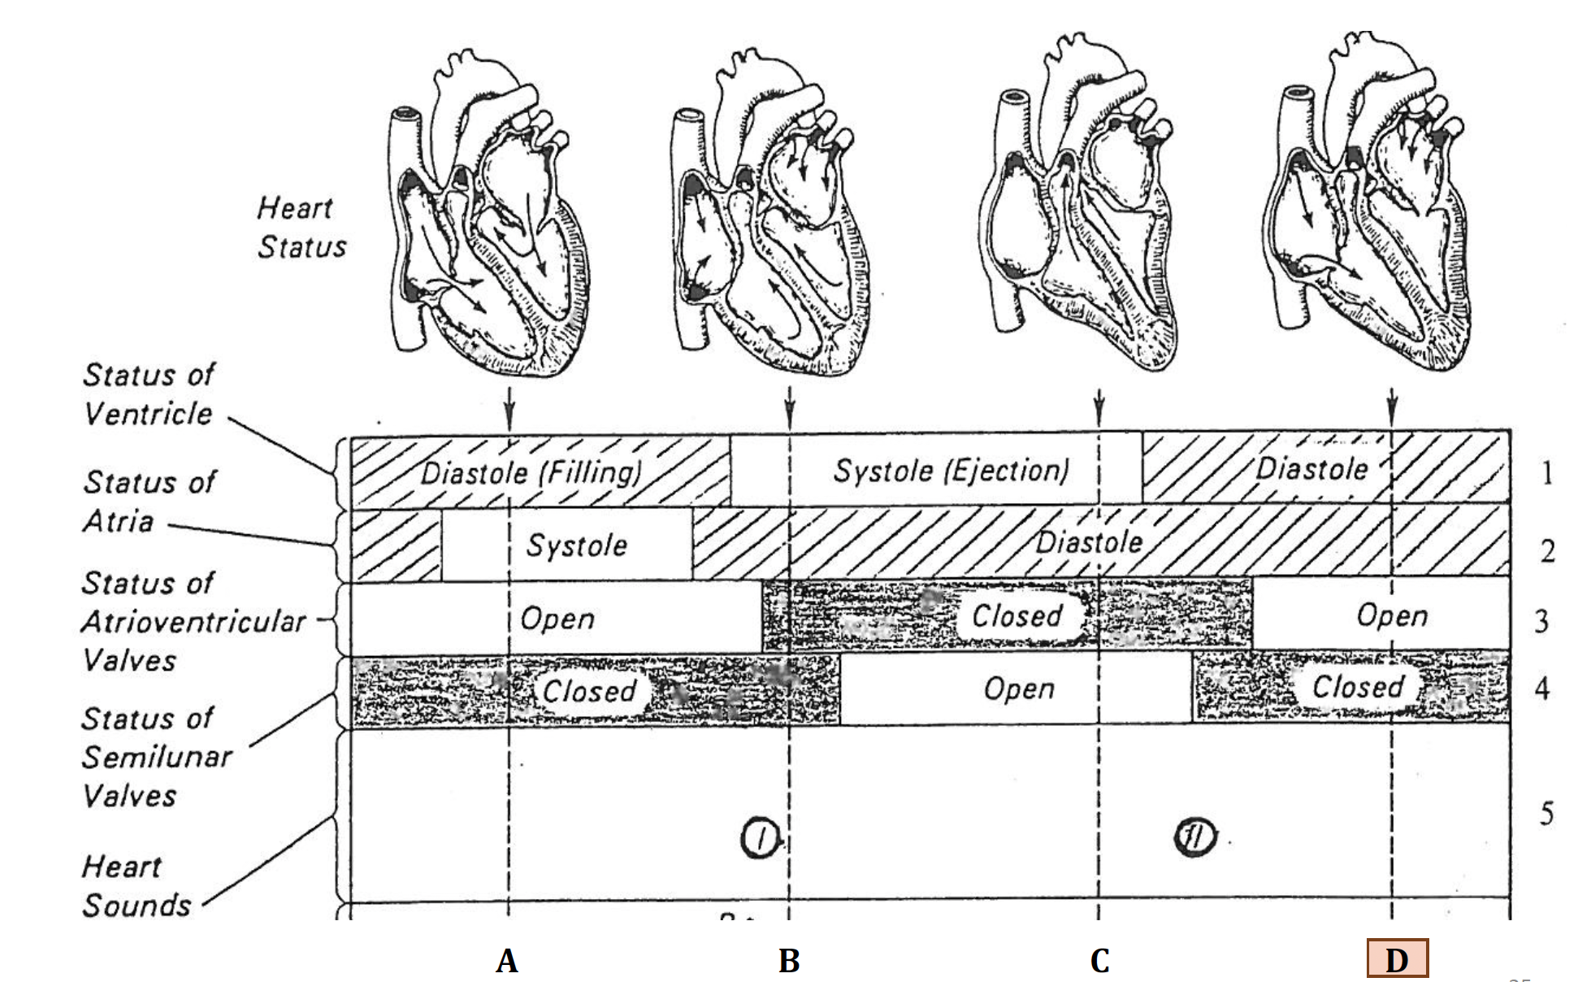

When in stage “D”, the ventricles have negative pressure which moves blood through the veins to the atria

LUBDUB

THE LUB→ the closing of the AV valves
THE DUB→ the closing of the semilunar valves

