Energy travels through space via electromagnetic radiation or radiant energy
→ Although radiant energy comes in different types, they all travel at the speed of light in a vacuum (2.998 x 10⁸ m/s²)
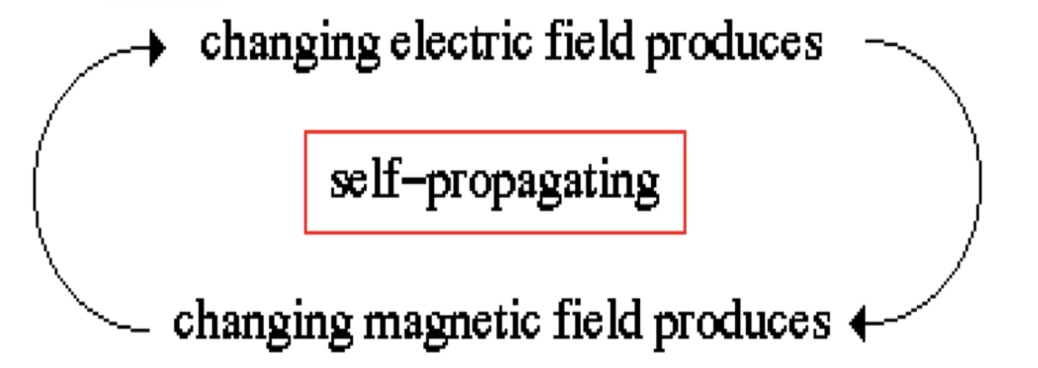

EMR’s→ part of the electromagnetic field→ have an electric component and magnetic component→ HAVE TO BE TOGETHER

Name of electromagnetic radiant comes from its magnetic fields which simultaneously oscillate in planes mutually perpendicular (90°) to one another and to the direction of the propagation in space

We know light is a wave because of diffraction patterns→ speed of light VARIES in different media
THE SPEED OF LIGHT WE USE IS THAT IN A VACUUM

Waves are characterized by wavelength, frequency, and speed.

Wavelength ($λ$)→ distance between two troughs (peaks) on a wave
Frequency ($ν$, Hz)→ number of waves (or cycles) that pass a given point in space per second
Speed ($c$, m/s)→ The speed the wave travels (the speed of light in a vacuum)

Wavelength ($λ$) and frequency ($ν$) are inversely related
$λ ∝$$\frac{1}{ν}$

Low Energy→ Low Frequency→ Large Wavelength
Red end of the color spectrum

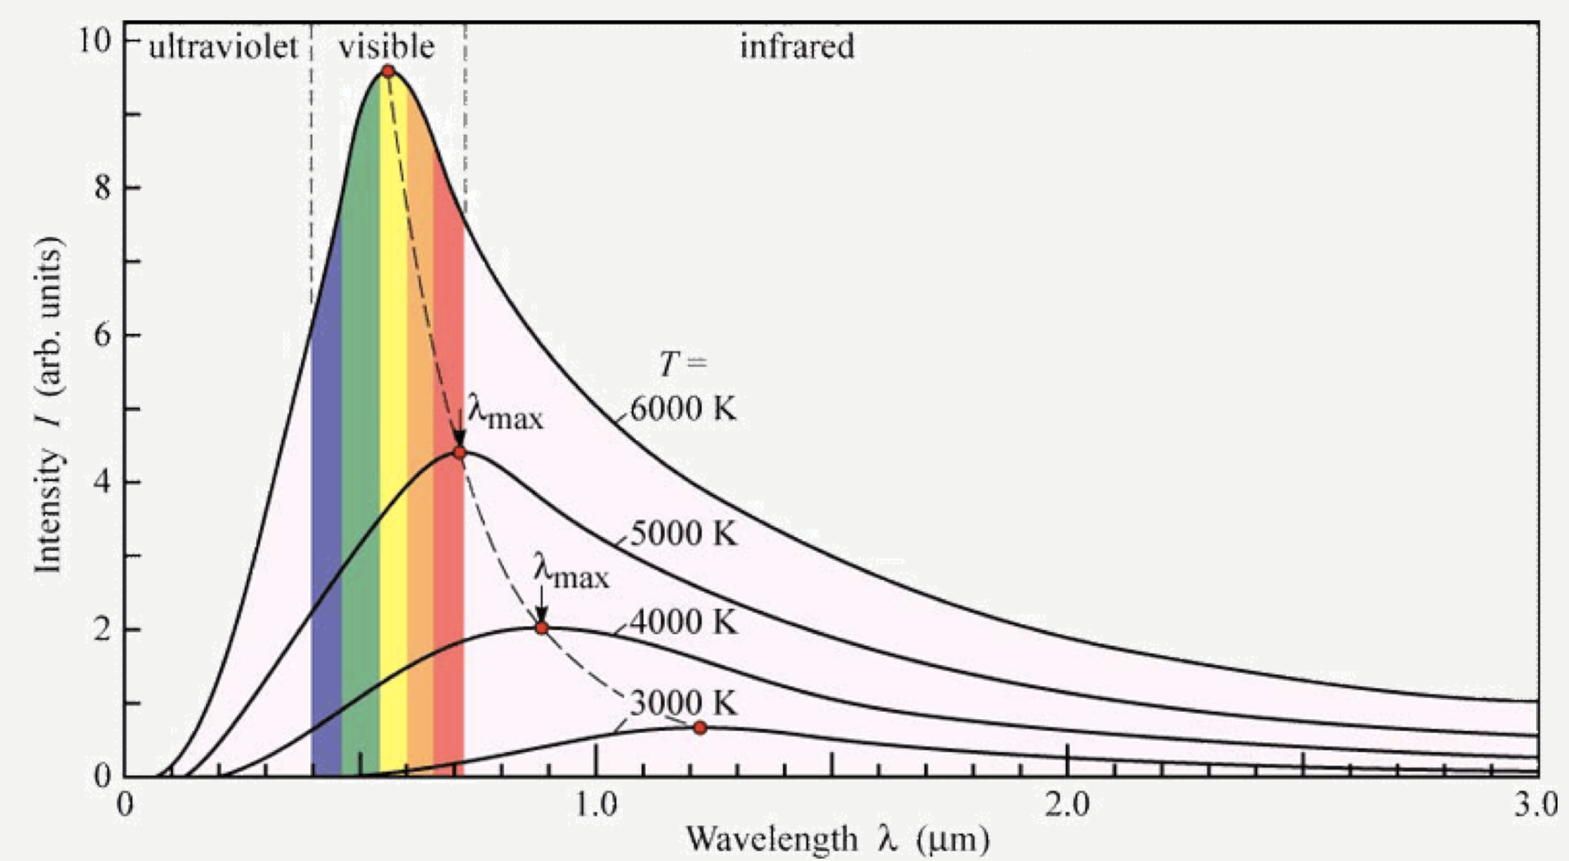
BLACKBODY RADIATION→ Emits radiation (of size $hv$) at various wavelengths in quanta→ as temp increases, wavelength decreases→ modeling with classical theory incorrectly predicts as we approach the ultraviolet we go to infinite energy→ theory and observation don't match
→ each quanta of energy of size $hv$→ only emits energy in quanta→

The classical theory of energy predicts matter can absorb or emit any quantity of energy, and that its radiation profile has no maximum and goes to infinite intensity at very short wavelengths (called the ultraviolet catastrophe effect)

Energy can be gained or lost ONLY in whole number multiples of $hv$

The change in energy of a system can be represented by the equation
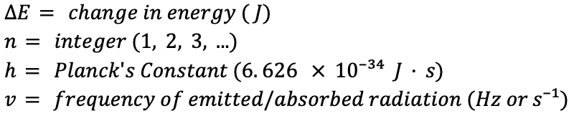

$ΔE= nhν$

Energy is quantized→ Can only be transferred in discrete units of size $hv$
→ each of these small packets of energy is called a quantum
→ energy can only be transferred in whole quanta

Electromagnetic radiation itself is quantized and can itself be viewed as a “stream” of photons
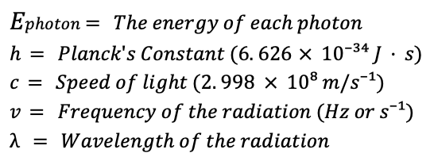

$E$$photon$ $= hν =$ $\frac{hc}{λ}$

The photoelectric effect refers to electrons being emitted from the surface of metal when light strikes it.

It can be characterized by;
- No electrons are emitted by a given metal below a specific threshold frequency $v₀$
- For light with frequency lower than the threshold frequency, no electrons are emitted regardless of the intensity of the light
- For light with frequency greater than the threshold frequency, the number of electrons emitted increases with the intensity of the light.
- For light with frequency greater than the threshold frequency, the kinetic energy of the emitted electrons increases linearly with the frequency of the light

The threshold frequency represents the minimum energy required to remove the electron from the metals surface

$Minimum energy required to remove the electron = E₀=hv₀$

- A photon with less energy than $E₀$ $(v<v₀)$ cannot remove electrons as is has a frequency less than the threshold frequency
- A photon with more energy than the threshold frequency, $E₀$ $(v>v₀)$, will remove the electron and give the excess energy to the electron as kinetic energy
- $E₀$ is also referred to as $ϕ$

$ϕ= the WORK FUNCTION$
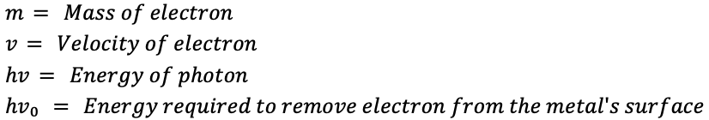
$KE$$electron$ $=$$\frac{1}{2}$$mv²=hv-hv₀$

$KEelectron= the kinetic energy of the emitted electron$

The intensity of light is measured as the number of photons present in a given part of the beam. When $v>v₀$, a higher intensity means that more photons are present to release electrons

Mass associated with a given quantity of energy
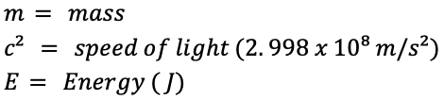
$E= mc²$ ~ $E=$$\frac{m}{c²}$

Photons however DO NOT HAVE MASS and ARE NOT affected by gravity
→ Photons have momentum which is an intrinsic property of the photon, not dependant on mass or velocity

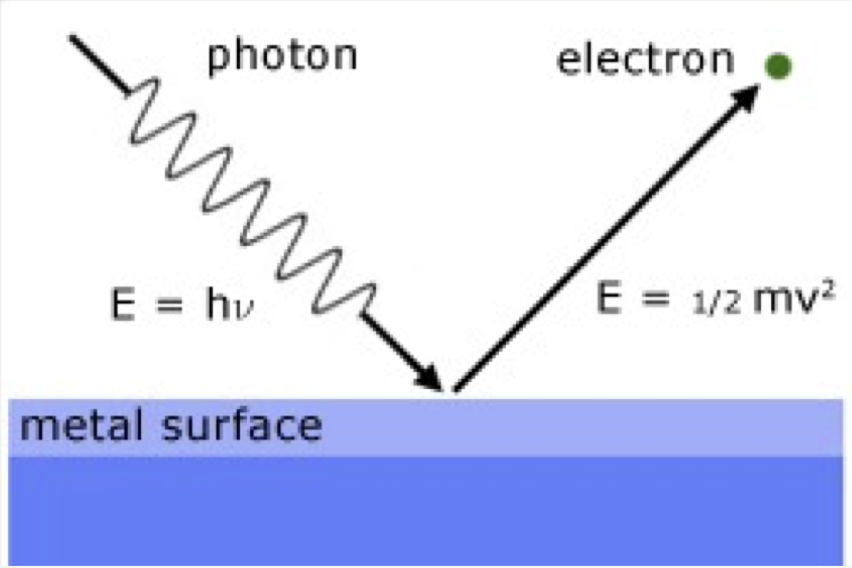
The wavelength of the emitted photon can then be calculated
$ΔE= h$ ($\frac{c}{λ}$) OR $λ=$($\frac{hc}{ΔE}$)

$E$$electron$ $=$$\frac{1}{2}$$mv²$ The energy of an emitted electron
NOTE THAT
$ν$ IS FREQUENCY & $v$ IS VELOCITY

The Dual Nature of Light refers to it having both wave properties and particulate properties

De Broglie’s equation derives wavelength from momentum
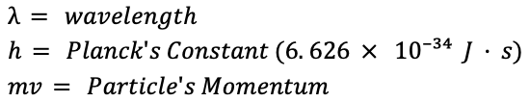
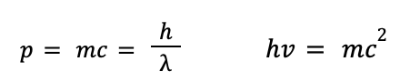
$λ=$$\frac{h}{mv}$

The wavelength of a given electron is of the same order as the spacing between the atoms in a typical crystal

Diffraction results when light is scattered from a regular array of points or lines created by an array of objects/crystals
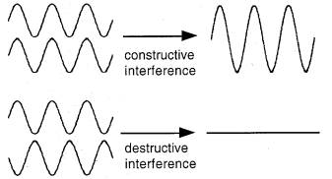
- Diffraction patterns result from constructive and deconstructive interference, interactions typical of waves.

  - Constructive interference→ Occurs when two IN phase waves interact and the peaks of one wave match that of another→ MORE INTENSITY
  - Deconstructive interference→ Occurs when two OUT of phase waves interact and the peak of one wave matches the trough of another→ LESS INTENSITY
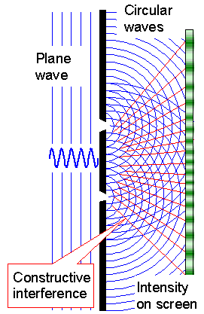
Bright spots/areas on the detector screen result from constructive interference
Dark spots on the detector screen result from deconstructive interference

Energy is a form of matter
ALL matter exhibits both particulate and wave properties

$∙$ Large “pieces” of matter exhibit predominantly particulate properties with associated wavelengths being so small they are not observed
$∙$ Small “pieces” of matter exhibit predominantly wave properties with some display of particulate properties
$∙$ Matter of intermediate size exhibits both particulate and wave properties

The energy of the electron in the hydrogen atom is quantized
The change between two discrete energy levels emits a photon of light

The quantum model for the hydrogen atom
- The electron in the hydrogen atom moves around the nucleus only in certain allowed circular orbits

Energy levels available to the electron in the hydrogen atom
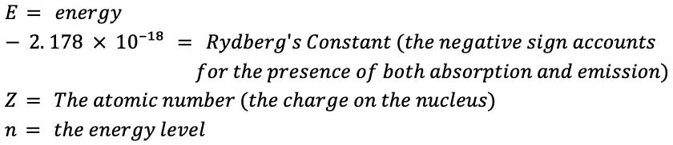
$ΔE= -2.178×10⁻¹⁸ J$$(\frac{Z²}{n⋅final²}$ - $\frac{Z²}{n⋅initial²})$

$E= -2.178×10⁻¹⁸ J$$(\frac{Z²}{n⋅final²})$

Negative value→ Emission (of a photon)→ More stable state
Positive value→ Absorption→ Less stable state
The above equation ONLY works for 1-electron systems
At $n=1$ , the electron is in its ground state.
↳In its ground state, the electron is the most tightly bound to its orbit.
At$n>1$ , the electron is said to be in its excited state→ higher energy

ENERGY CAN BE NEGATIVE OR POSITIVE→ WAVELENGTH CANNOT BE NEGATIVE

The bohr model is fundamentally incorrect as it fails to fit the emission spectra of atoms with more than 1 electron.

Wave Mechanics or Quantum Mechanics

NODES→ zero lateral displacement
Since each end is FIXED with a NODE ON EACH END, there MUST be a WHOLE NUMBER of half wavelengths within a standing wave.

ONLY CERTAIN CIRCULAR ORBITS HAVE A CIRCUMFERENCE INTO WHICH A WHOLE NUMBER OF WAVELENGTHS OF THE STANDING ELECTRON WAVELENGTH WILL FIT.

ALL OTHER ORBITS→ NOT ALLOWED
→ they would produce DECONSTRUCTIVE INTERFERENCE

$Ĥψ= Eψ$

$ψ$ $= the wave function$
$Ĥ$ $= the operator (hamiltonian)$

The wave function is a function of the coordinates (x, y, z) of the electron's position in space
→ IT DOES NOT MEAN REAL WAVES→ IT MEANS PROBABILITY WAVES
→ coordinates on the x, y, and z plane indicate 3 DIMENSIONALITY

- An operator is a set of mathematical instructions that acts on a function to produce another function
- The hamiltonian gives back the original function multiplied by a constant, in this case the constant E (the total energy of an atom (the sum of PE due to the attraction of the proton and electron and the KE of the moving electron)

The wave function, $ψ$, has many solutions each of which is characterized by the value of E

A specific wave function for a given electron is called an ORBITAL

The heisenberg uncertainty principle→ shows there is FUNDAMENTAL LIMITATIONS to how precisely we can know both the position and momentum of a particle at a given time
→ sometimes called the indeterminacy principle

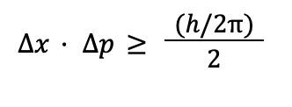
$Δx$ = the uncertainty in the particle's position
$Δp$ = the uncertainty in the particle's momentum ($p=mv)$
$h$= planck’s constant ($6.626×{10}^{-34} J⋅s$)

THE MINIMUM UNCERTAINTY IN THE PRODUCT OF $Δx⋅Δp$ IS $\frac{h}{4π}$
THIS EQUATION SHOWS THAT THE MORE WE KNOW ABOUT THE PARTICLE'S POSITION, THE LESS WE KNOW ABOUT ITS MOMENTUM AND VICE VERSA

Are electrons moving?→ We don't actually know if the electron is even moving around an atom.
→ because the uncertainty principle implies that since we CANNOT KNOW THE EXACT PATH OF
AN ELECTRON AS IT MOVES AROUND THE NUCLEUS, it is NOT APPROPRIATE TO
ASSUME IT IS MOVING IN A WELL DEFINED ORBIT (such as depicted in the Bohr model)

$ψ^{2}=$$The PROBABILITY of an electron being found in a certain region in space$
$=$ $The ELECTRIC CHARGE DENSITY at location x and time T$ ooooooooooooooo

STANDING WAVES FORM INTERFERENCE PATTERNS

QUANTUM NUMBERS

QUANTUM NUMBERS→ numbers that show where at electron in an atom will be found
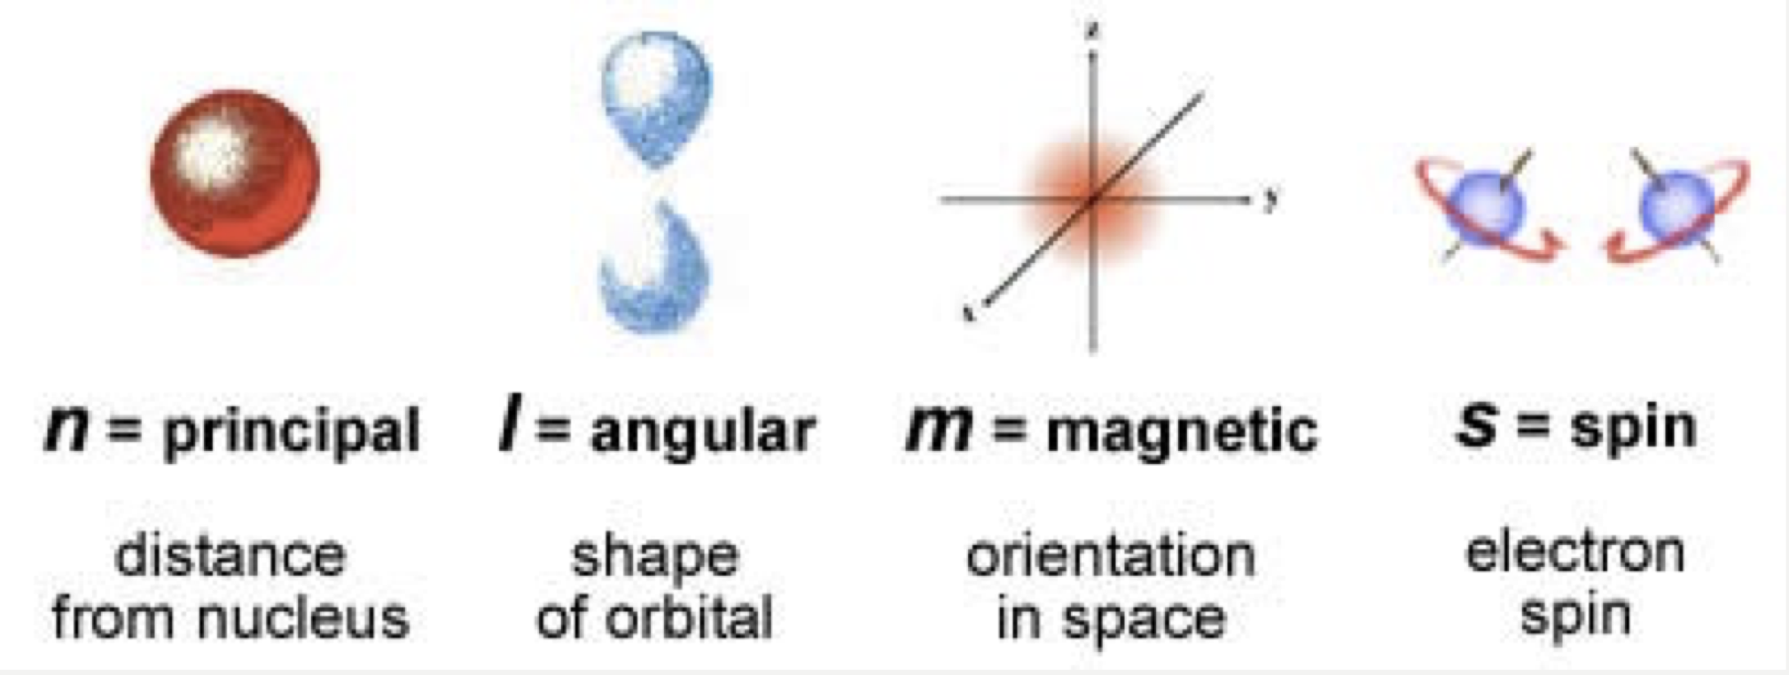
As $n$ gets bigger, distance from the nucleus gets larger
→ Has values from $1≤n$
L has integral values from 0 → ($n-1$)
$m$L can have values from -L to +L
$m$$s$ ONLY has 2 possible values: + ½ or -½
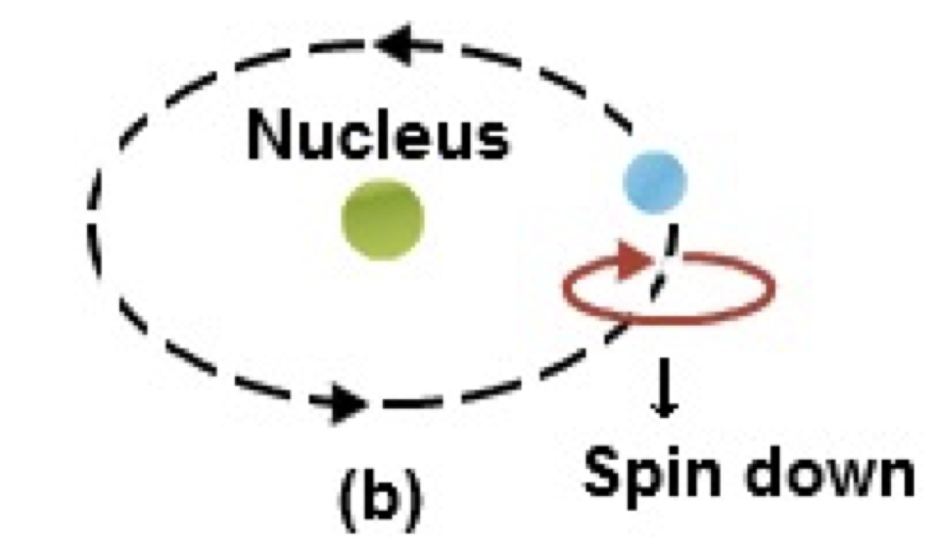
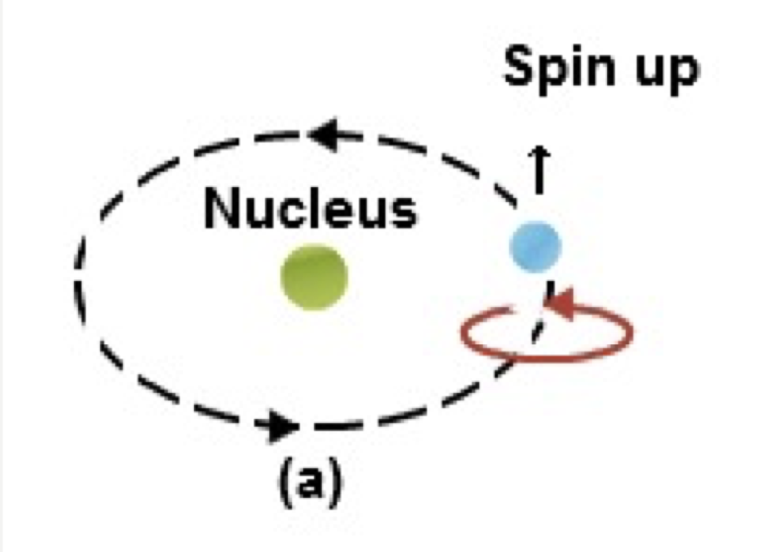
4 lobes→ d orbital
2 lobes→ p orbital
1 lobe (sphere)→ s orbital

THE PAULI EXCLUSION PRINCIPLE→ NO ELECTRONS CAN HAVE THE SAME SET OF QUANTUM
NUMBERS
THE PAULI PRINCIPLE→ AN ORBITAL CAN ONLY HOLD 2 ELECTRONS & THEY MUST HAVE OPPOSITE
SPINS
→ HOW TO REMEMBER: PAU

1s
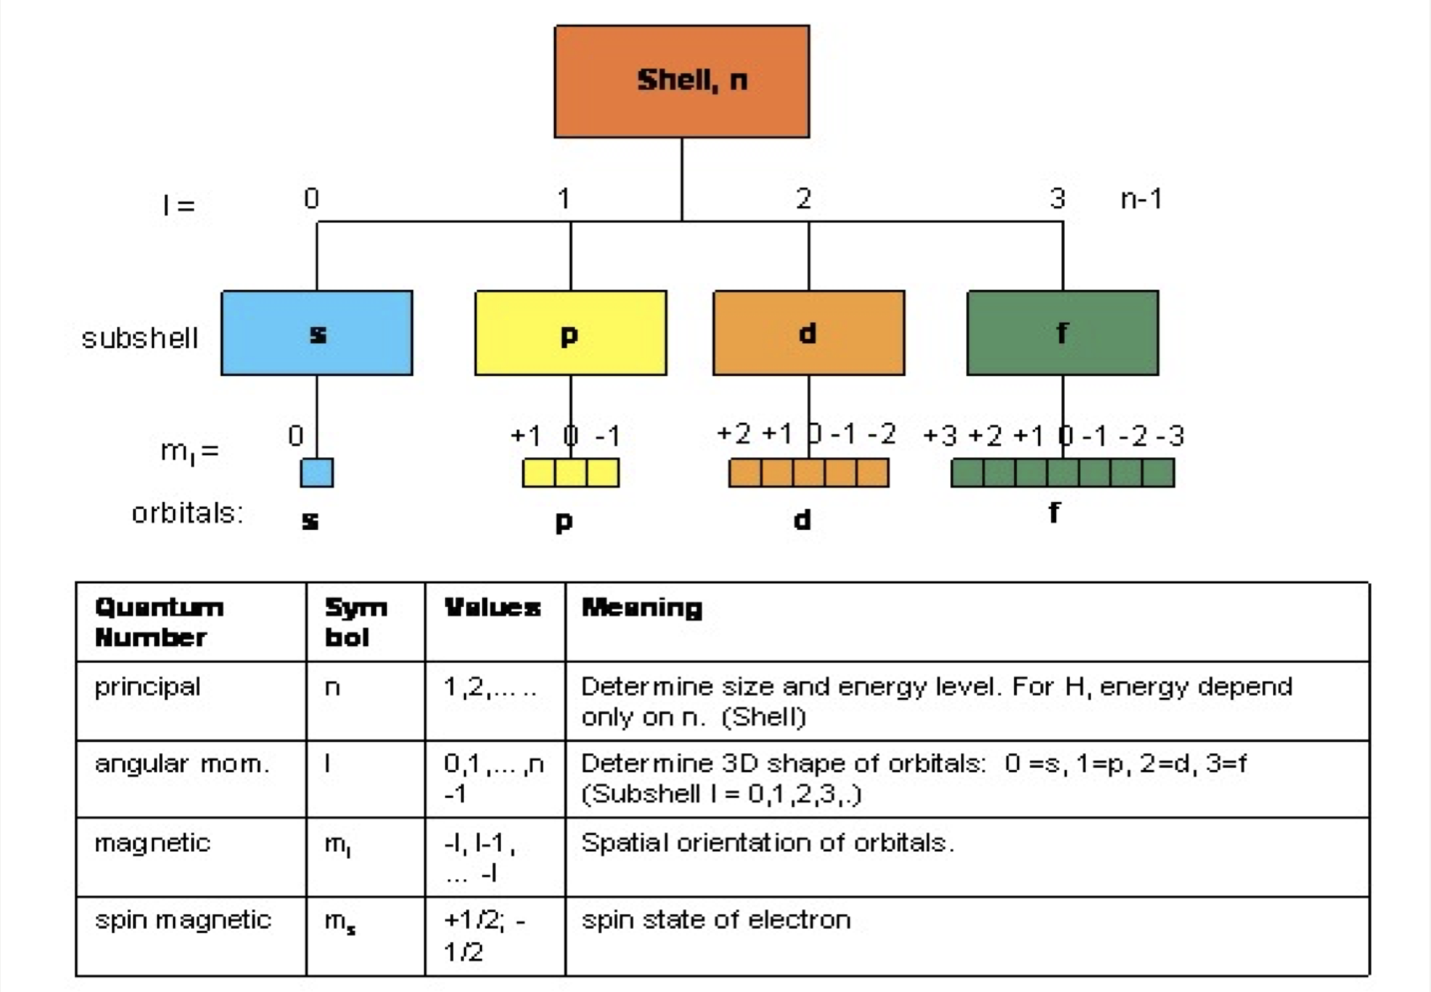

★ Number of electrons in energy state= $2n²$
★ Number of electrons in orbitals = # of orbitals $×$ 2 ★ # of orbitals = 2L + 1

For hydrogen→ All orbitals are degenerate (equal energy)
→ $E$$ns$ $=E$$np$ $=E$$nd$ $=E$$nf$

For Polyelectronic atoms→ energy depends on $n$ & $L$
→ $E$$ns$ $<E$$np$ $<E$$nd$ $<E$$nf$

POLYELECTRONIC ATOMS→ atoms with more than 1 electron
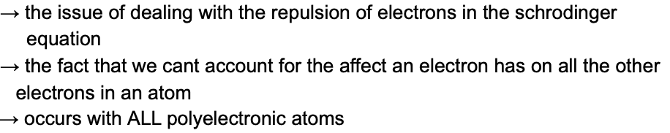

ELECTRON CORRELATION PROBLEM

Apparent nuclear charge = effective nuclear charge

$Effective nuclear charge=$$Z$$actual$$- effect of electron repulsion$

TRIADS→ patterns found in three elements with similar properties found within the periodic table (ex. Cl, Br, I )

THE Aufbau PRINCIPLE→ as protons are added one by one to the nucleus to build up elements, electrons are simultaneously added to these atomic orbitals→ works for valence electrons!

The 2s orbital→ lower in energy than the 2p orbital

HUND'S RULE→ the lowest energy configuration for an atom is the one having the maximum number of unpaired electrons allowed by the Pauli principles in a particular set of degenerate orbitals

2px
2py
2pz
DEGENERATE ORBITALS

DEGENERATE ORBITALS→ electron orbital subshells within the same energy level
→ there are 3 degenerate orbitals (2px, 2py and 2pz) in
the 2p orbital

VALENCE ELECTRONS→ the electrons in the outermost principal quantum level of an atom
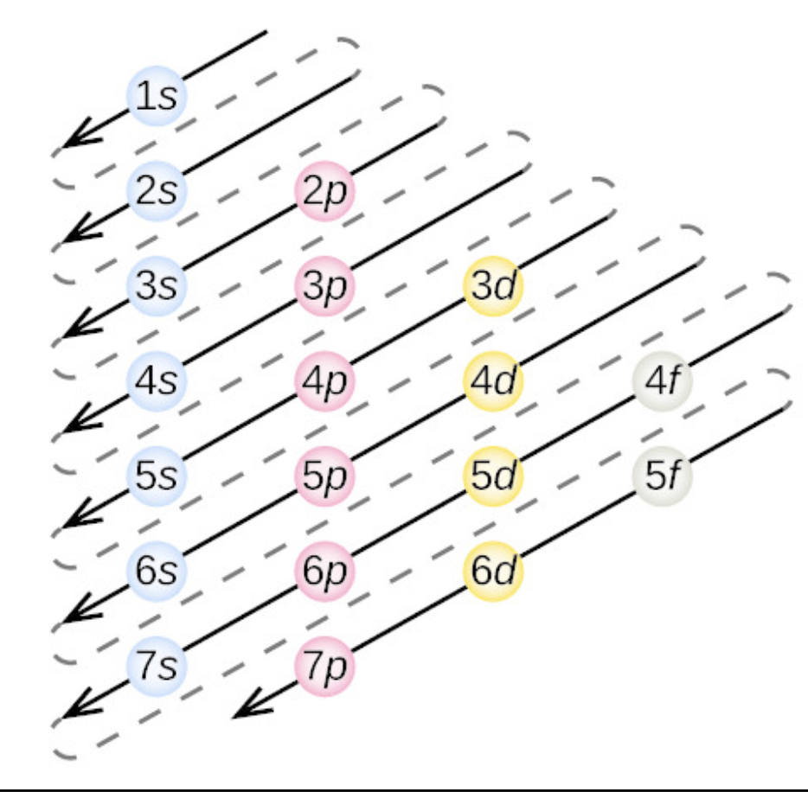
→ (ex. A line in the christmas tree)
→ are NEVER in the found in the d-orbital
CORE ELECTRONS→ the innermost electrons

★ Elements with the same number of valence electrons have similar properties
★ Elements in each group (column) share the same number of valence electrons

VALENCE ELECTRON CONFIGURATIONS
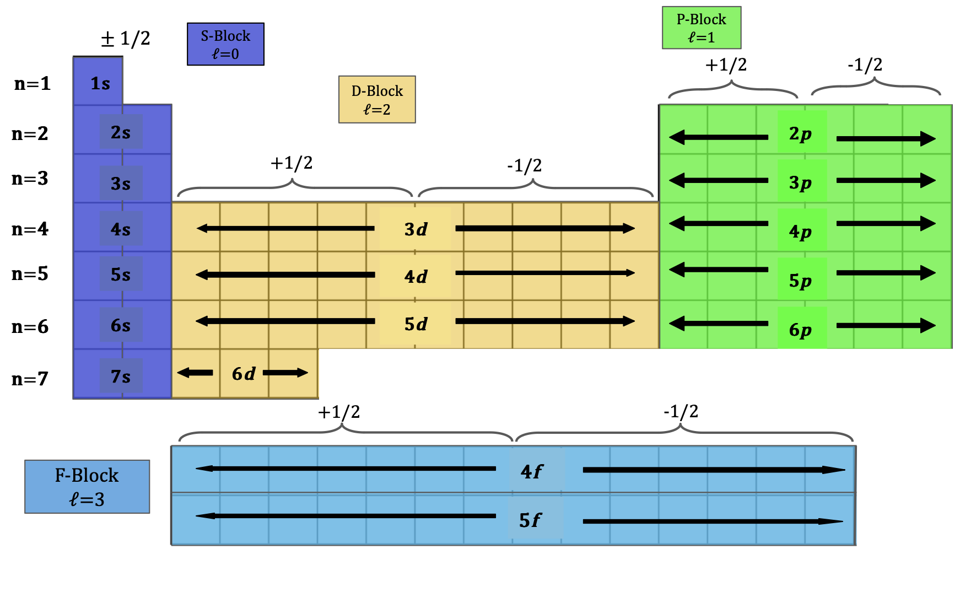

- The $(n+1)$s orbitals fill before the $nd$ orbitals
- Lanthanides→ $4f$ orbitals are filled
- Actinides→ $5f$ orbitals are filled

- The group labels 1A, 2A, 3A, 4A, 5A, 6A, 7A,
8A indicate the number of valence electrons
every element in the group has
- Also called the representative groups
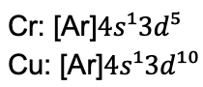
ELECTRON CONFIGURATION FOR CHROMIUM AND COPPER ARE WEIRD
↳ TRANSITION METALS ARE WEIRD AS FUCK
↳ Provides “special stability”

ALL TRANSITION METALS→ have 2 valence electrons

CATIONS→ remove electrons from highest occupied orbital
ANIONS→ add electrons to the lowest unoccupied orbital

Elements do as much as they can to have the same configuration as the noble gasses

NUMBER OF NODES (where electrons will not be found) IN S ORBITALS = $n$$s-1$

S ORBITALS→ CONTAIN 90% OF THE TOTAL ELECTRON PROBABILITY WITHIN

P-ORBITALS AND NODAL PLANES→ EQUAL PROBABILITY OF FINDING ELECTRONS ON BOTH SIDES OF PLANE
2px orbital has a z-y nodal plane 2py orbital has a z-x nodal plane 2pz orbital has a x-y nodal plane

For d-orbitals, the x,y,z following the d is representative of the nodal plane it experiences

↑ $n$ value→ ↑ radius of the shell→ ↑ average electron distance from the nucleus increases

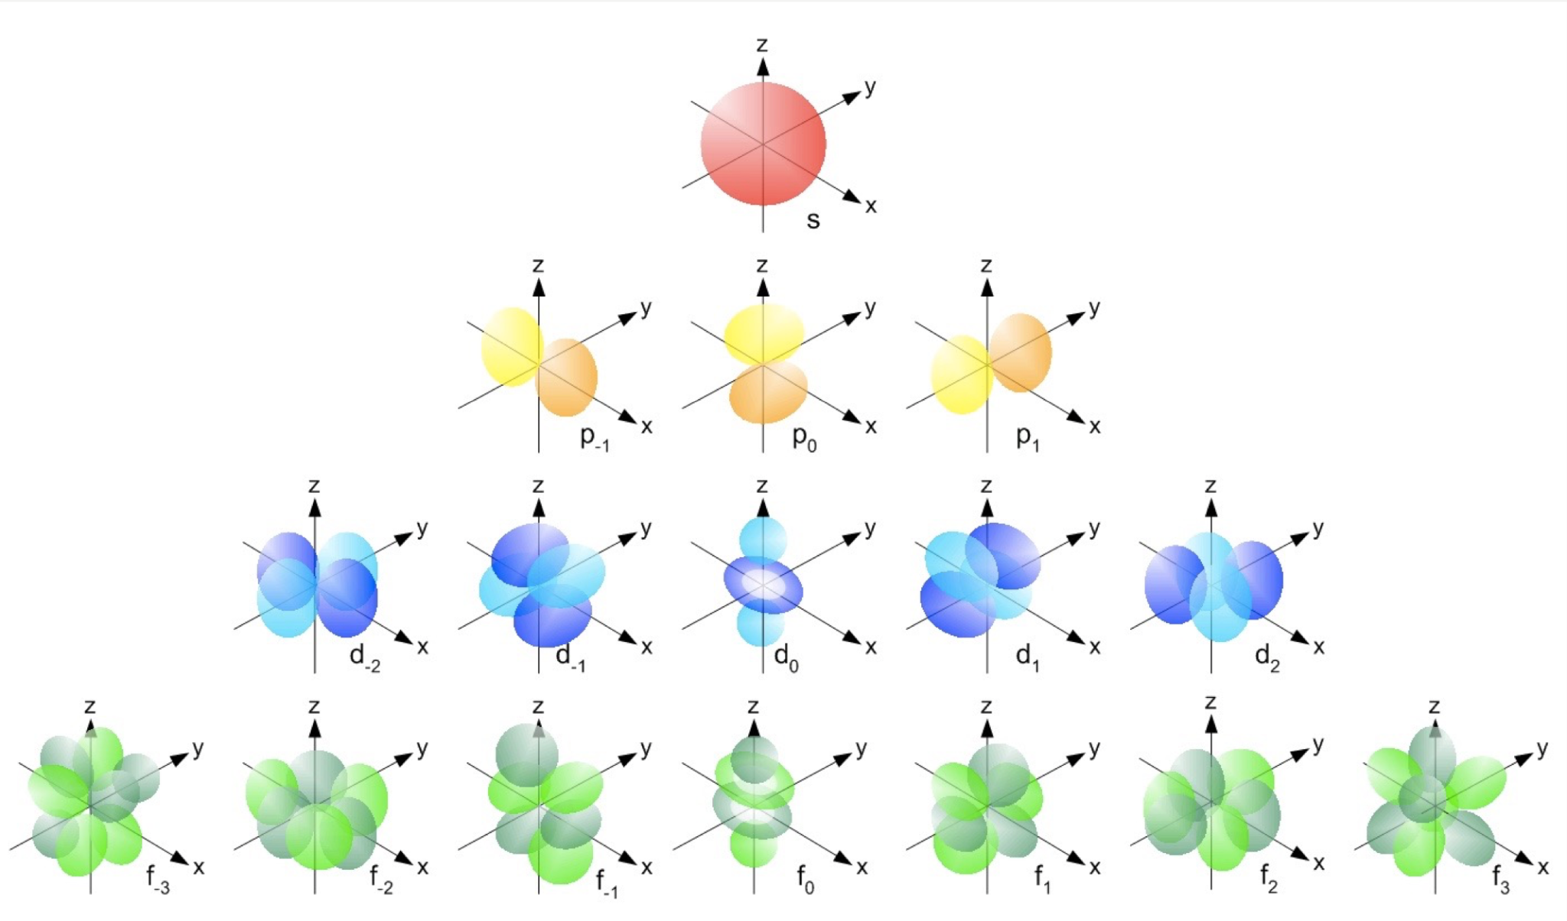

PERIODIC TRENDS
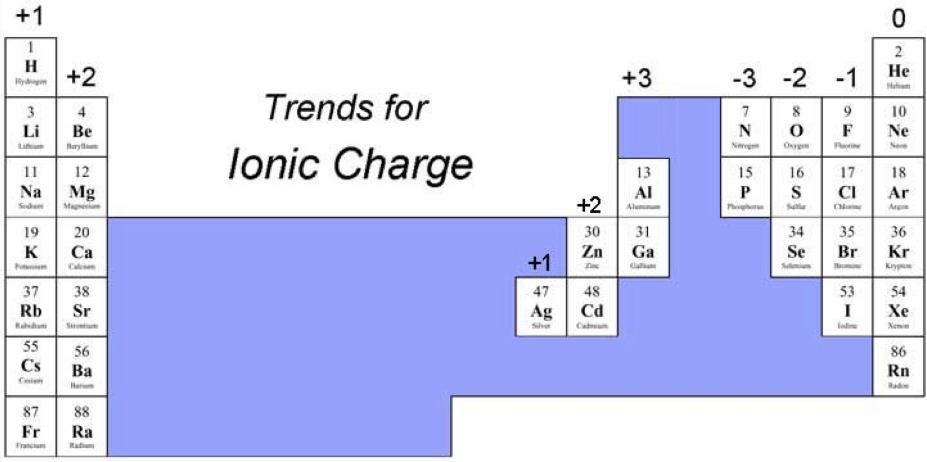

PURPLE AREAS are areas where charges vary or assigning an ionic change is not appropriate

★ ATOMS ARE LAZY!
Left hand side where charges are positive→ gaining one electron is easiest
Right hand size where charges are negative→ easiest to lose an electron

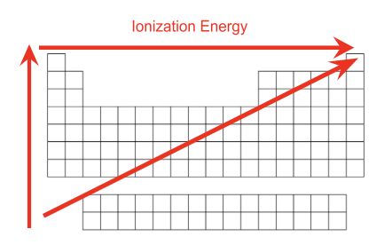
IONIZATION ENERGY→ the energy required to remove an electron from
a gaseous atom or ion where the atom or ion is in its ground state
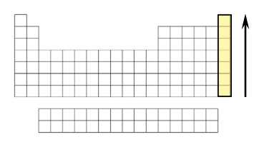
Ionization energy increases going up
the noble gasses column

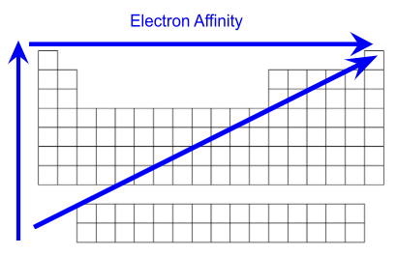

ELECTRON AFFINITY→ The energy change associated with the
addition of an electron to a gaseous atom or
Ion where the atom or ion is in its ground state
→ increases as more electrons are added to each
orbital
→ IS EXOTHERMIC IF IT FORMS A STABLE
NEGATIVE ION
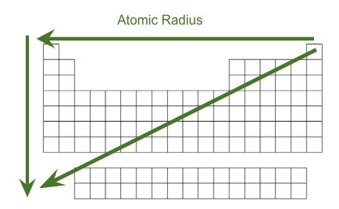

ATOMIC RADIUS→ half the distance between two (of the same) atomic
nuclei

Ionic radius

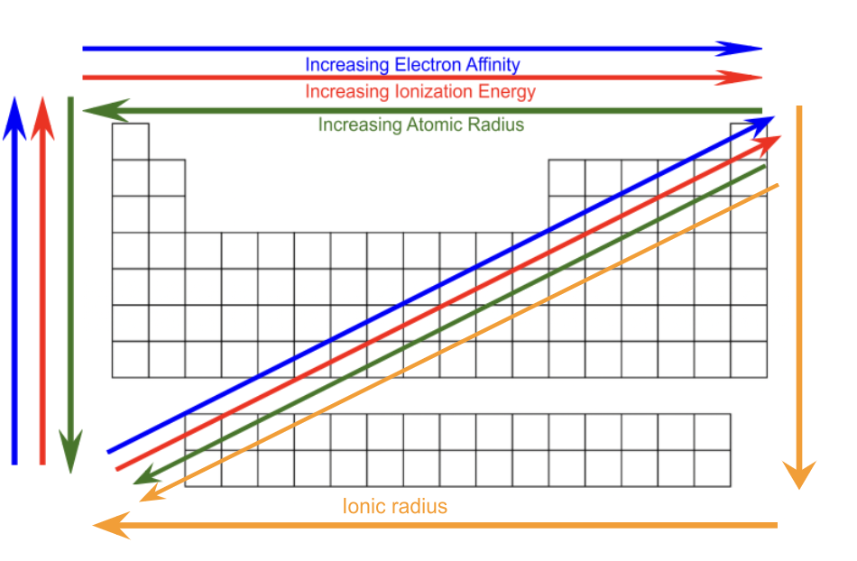
OVERALL TRENDS

