Xylem and phloem→ often found adjacent to each other→ both specialized for transporting fluids

Translocation→ the movement of sugars by bulk flow in multiple directions
Specifically from sources→ sinks.
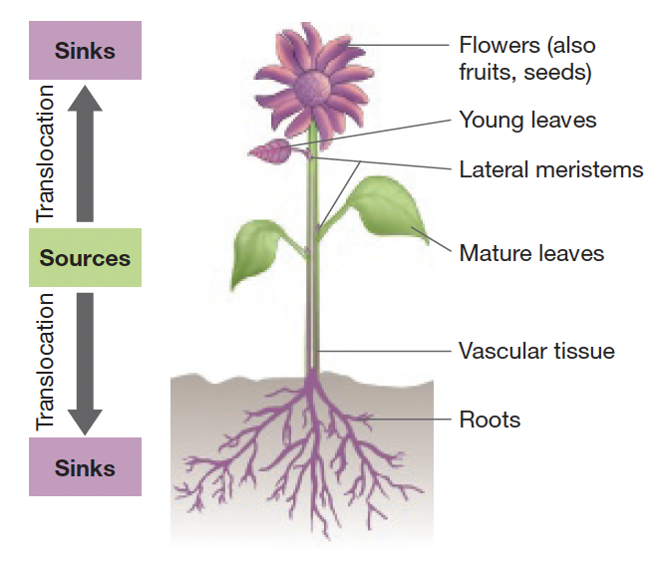
source→ a tissue where sugar enters the phloem
sink→ a tissue where sugar exits the phloem

During growing season→ Mature leaves and stems actively produce sugar in excess
act as sources.

Early growing season→ sugars move from storage
Storage cells in roots and stems act as sources→ developing leaves act as sinks

1. Sugars can be translocated rapidly—typically 50–100 centimeters per hour (cm/hr).
2. There is a strong correspondence between the physical locations of sources and sinks
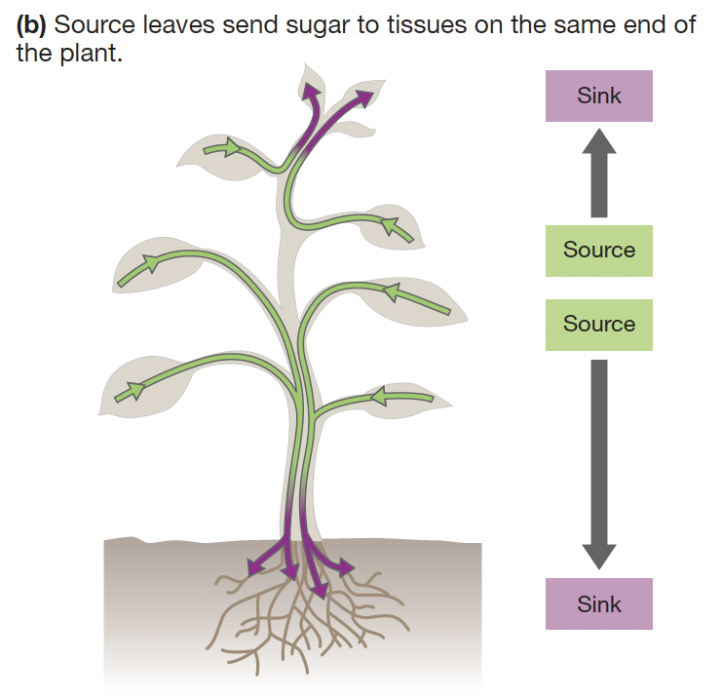
Leaves acting as sources→ send sugar to tissues on the same side of the plant

Tall plants→ leaves on upper part of stem→ send sugar to apical meristems
leaves on lower part of plant→ send sugar to the roots

Phloem→ consists of sieve-tube elements and companion cells
- Both are alive at maturity and lack secondary cell walls.

Pores→ enlarged plasmodesmata
- create a direct connection between the cytoplasms of adjacent cells

sieve-tube elements→ represent a continuous system for transporting sugar throughout the plant body.
- sieve-tube elements lack nuclei and most organelles
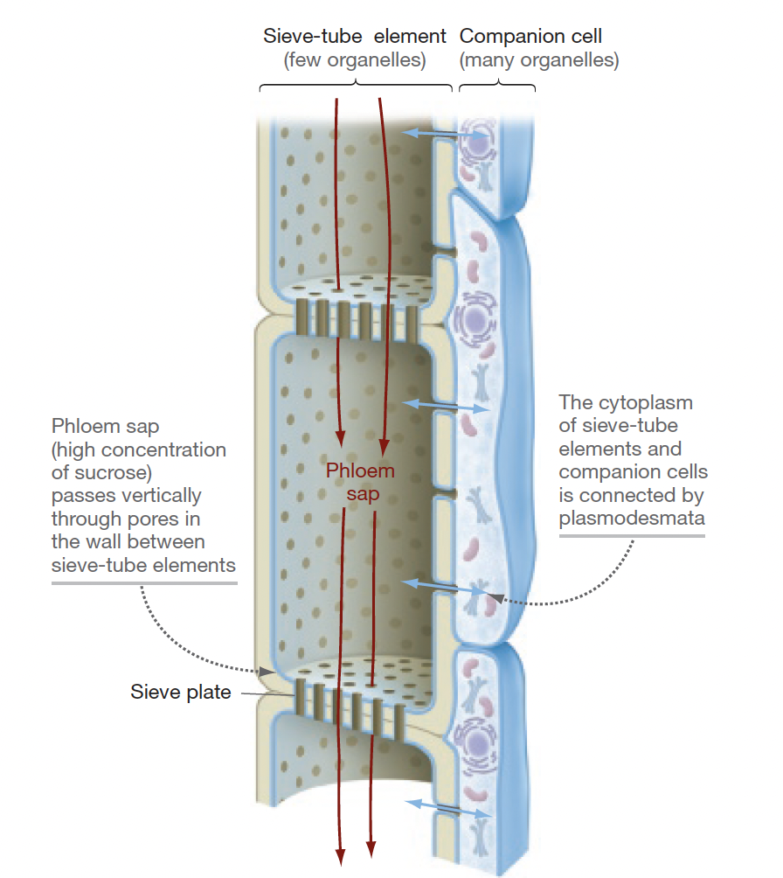
- connected to one another, end to end, by perforated sieve plates

Companion cells→ “support staff.”
- have nuclei and a rich assortment of ribosomes, mitochondria, and other organelles.
- located adjacent to sieve-tube elements and function as their supports

phloem in primary and secondary vascular tissue→ continuous throughout the plant
- direct anatomical connection from phloem in the tips of shoots→ tips of roots

Vascular bundles→ contain xylem and phloem, run the length of plants
- certain bundles extend into specific branches, leaves, and lateral roots

Phloem sap→ does NOT move from one vascular bundle to another→ each bundle is independent.
- sap that flows through vascular tissue→ dominated by sucrose (table sugar)
- can contain small amounts of minerals, amino acids, mRNAs, hormones

pressure-flow hypothesis→ events at source tissues and sink tissues create a pressure potential gradient in phloem
- The water in phloem sap moves down pressure gradient
- sugar molecules are carried along by bulk flow

necessary force is generated by;
- differences between turgor pressure in the phloem near source tissues
- turgor pressure in the phloem near sink tissues

sucrose moves from source cells→ companion cells and then companion cells→ sieve-tube elements

phloem sap in the source tissue→ high concentration of sucrose.
- Because of phloem loading
Compared to the water in the adjacent xylem cells → phloem sap has a very low solute potential.

water moves along a water-potential gradient
- Passively flows from xylem→ selectively permeable plasma membrane of sieve-tube elements
- turgor pressure begins to build in the sieve-tube elements in the source region.

Cells in the sink→ remove sucrose from the phloem sap by passive or active transport.
- Results in a loss of solutes
- water potential in sieve-tube elements increases
  - becomes higher than the water potential in adjacent xylem cells
- water flows across the selectively permeable membranes of sieve-tube elements into xylem along a water-potential gradient
  - turgor pressure in the sieve-tube elements in the sink drops

The Net Result→ high turgor pressure in phloem at a source tissue and low turgor pressure at the sink
- Difference in pressure drives phloem sap from source→ sink via bulk flow
- One-way flow of sucrose and a continuous loop of water movement.
  - Water returns to the source tissue via the xylem.

Creating differences in turgor pressure→ requires an expenditure of energy to;
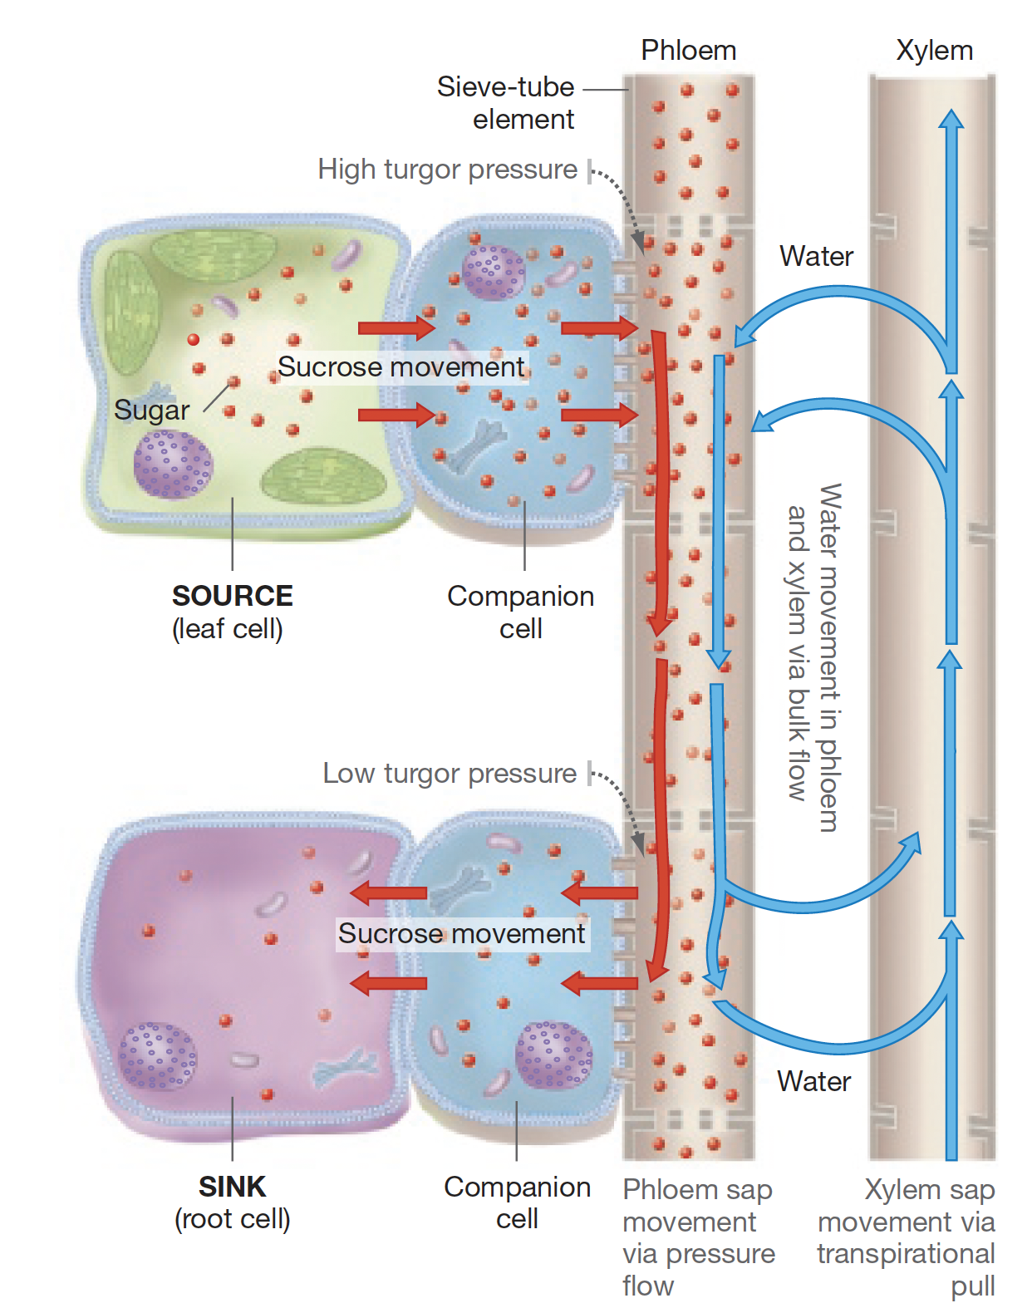
- set up a water-potential gradient in phloem.
- create high pressure potential in sieve-tube elements near source cells
  - large amounts of sugar have to be transported into the phloem sap
    - enough to raise the solute concentration of sieve-tube elements

